Drive specialist with new sales company on the market
FAULHABER with new location in Denmark
Drive specialist FAULHABER announces the opening of its new location in Denmark on June 1, 2024. In Allerød, north of Copenhagen, the company will take over sales and consulting directly instead of via its partner Compower ApS as before. The focus of the newly founded FAULHABER Danmark ApS is on strengthening customer proximity.
Mireille Deckers-Strobel, Head of Global Sales at FAULHABER, summarizes: “Our drive systems are known in the global market for their performance and quality. Following the opening of our locations in the Netherlands, Poland, Austria and Italy in recent years, this further opportunity has now arisen in northern Europe. With our presence in Denmark, we can understand the needs of the local markets even better and be available to our customers in close proximity.”
By establishing the location, we are pursuing the opportunity to consolidate existing relationships and ensure faster response times. To achieve this, it is crucial to have a local presence. Claus Lauritsen will take on this task in future. He is very familiar with the local structures and has known FAULHABER's customers and products for many years. He will continue to focus on competent and individual advice, competitiveness and customized solutions. This strategy underlines FAULHABER's customer-oriented focus and at the same time strengthens future growth.
About FAULHABER
FAULHABER was founded in 1947 by Dr. Fritz Faulhaber in the Swabian town of Schönaich, south of Stuttgart. The company specializes in the development, production and use of microdrive systems, drive electronics and components. In addition to the extensive standard product range, customer-specific solutions are also implemented to a large extent. FAULHABER employs more than 2,300 people worldwide, including in the USA, Switzerland, Romania, Singapore and China.

The address of the new FAULHABER location:
FAULHABER Danmark ApS
Scandinavian Trade Building
Gydevang 39-41
DK- 3450 Allerød
 |  | 312 words / 2.049 characters
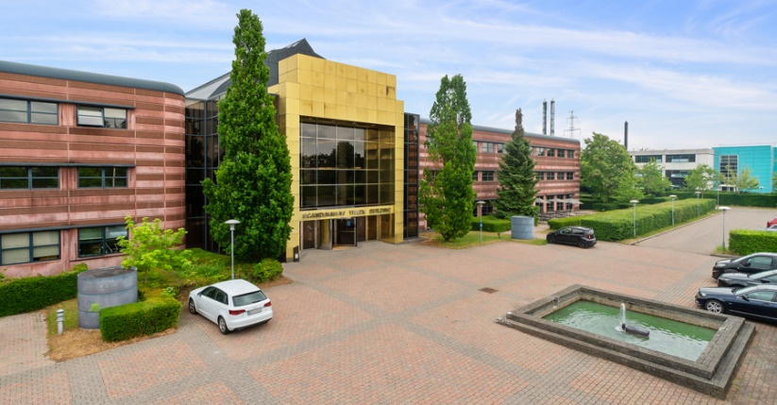 |  |  | FAULHABER_Denmark_Trade_Building© FAULHABER

Press contact (Germany + International)  Dr. Fritz Faulhaber GmbH & Co. KG  Kristina Wolff – Marketing  Faulhaberstraße 1 · 71101 Schönaich  Germany  T +49 7031 638-148 · F +49 7031 638-8148  redaktion@faulhaber.com | Press contact (Switzerland)  FAULHABER SA  Ann-Kristin Hage-Ripamonti – Marketing  6980 Croglio  Switzerland  T +41 91 61 13 239 · F +41 91 611 31 10  marketing@faulhaber.ch

