Award and recognition for outstanding partnership
SALEM SA receives FAULHABER Supplier Award
On May 14, 2024, the FAULHABER Supplier Award was presented to the Swiss company SALEM SA. The company specializes in CNC machining and has been a reliable partner of FAULHABER for 25 years.
“SALEM SA is an important supplier for us, as they supply several FAULHABER sites, such as Croglio and La Chaux de Fonds,” explains Jonathan Gonzalez, Head of Purchasing at FAULHABER SA in Switzerland. “They also have extensive expertise in the manufacture of strategic turned parts that are essential for our drive solutions, including flanges, stators, shafts, tubes and caps.” In addition to Jonathan Gonzalez, Stefano Cerioli (Strategic Buyer for turned parts) and Alexandre Pantel (Project Buyer) also attended the presentation of the supplier award to congratulate Managing Director Antonio Cataldo.
SALEM SA was founded in 1970, 15 years later Antonio Cataldo acquired the company and today employs ten people. FAULHABER benefits from the expertise and tireless support of Antonio Cataldo, his sons Sandro and Patrick and the customer-oriented team. This team ensures that both series production and small to medium-sized batches of complex parts are reliably manufactured. Thanks to great flexibility and fast turnaround times, new and specific projects can also be realized. Orders are completed on time and with high quality. SALEM SA is known for its high reliability and versatility and was one of the first suppliers to put in place FAULHABER SDI (Safety Dedicated Inventory).
Every year, one of around 600 suppliers is honored by FAULHABER. Various criteria are taken into account in the selection and evaluation process, such as product quality, delivery reliability, technical expertise, accessibility and cooperation. In 2023, the company SALEM SA came out on top in this regard.
 | 290 words / 1.875 characters
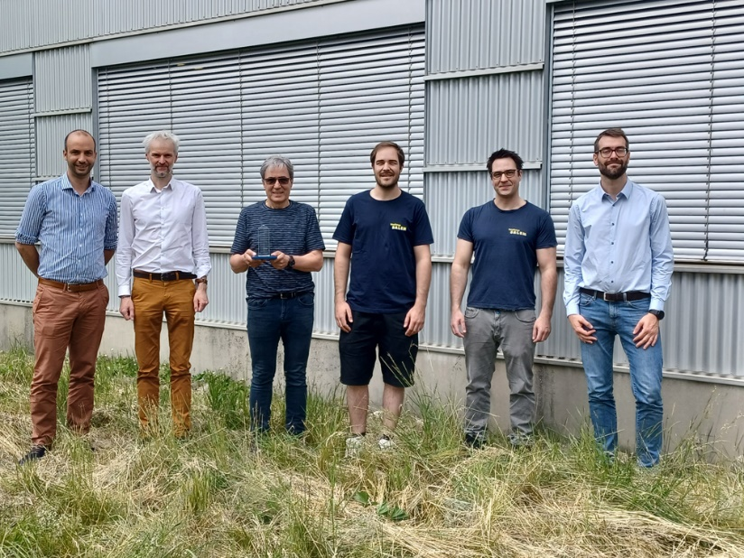 | SALEM SA receives FAULHABER Supplier Award_© FAULHABER

Press contact (Germany + International)  Dr. Fritz Faulhaber GmbH & Co. KG  Kristina Wolff – Marketing  Faulhaberstraße 1 · 71101 Schönaich  Germany  T +49 7031 638-148 · F +49 7031 638-8148  redaktion@faulhaber.com | Press contact (Switzerland)  FAULHABER SA  Ann-Kristin Hage-Ripamonti – Marketing  6980 Croglio  Switzerland  T +41 91 61 13 239 · F +41 91 611 31 10  marketing@faulhaber.ch

