Ranga Yogeshwar honors innovation achievements
FAULHABER is one of the TOP 100
Innovation champion for the 5th time: Dr. Fritz Faulhaber GmbH & CO. KG with headquarters in Schönaich has received the TOP 100 seal 2024. Science journalist Ranga Yogeshwar has been a mentor of the competition for 12 years and personally congratulated FAULHABER on this success at the award ceremony on June 28.
In the selection process with more than 100 criteria from five categories, particularly innovative medium-sized companies were honored. At the German SME Summit in Weimar at the end of June, all of the top innovators of the year 2024 gathered to receive their award. FAULHABER was particularly impressive in size category C (over 200 employees) in the categories "Innovation-promoting top management" and "External orientation/open innovation". The TOP 100 company portrait published on the occasion of the award states (excerpt):
When modern surgical robots perform precise incisions, in many cases miniature motors from Dr. Fritz Faulhaber are behind them. Since its foundation in 1947, the company has built up a worldwide reputation as a supplier of the smallest drives. Whether particularly small or easy-to-clean drives for medical devices or particularly robust miniature motors for aerospace technology: "Our task begins where extreme conditions require extraordinary new drives," says Managing Director Dr. Udo Haberland. For him, the creative solution ideas of his employees are the greatest innovation treasure to be unearthed. "We wanted to create the freedom to creatively test new technological approaches as a team," he says. The company is often connected to its customers through many years of development work, which has triggered many new ideas. Joint discussions about industry trends and new challenges on the customer side are therefore part of the successful external orientation of the medium-sized company.

 | 293 words / 1.191 characters
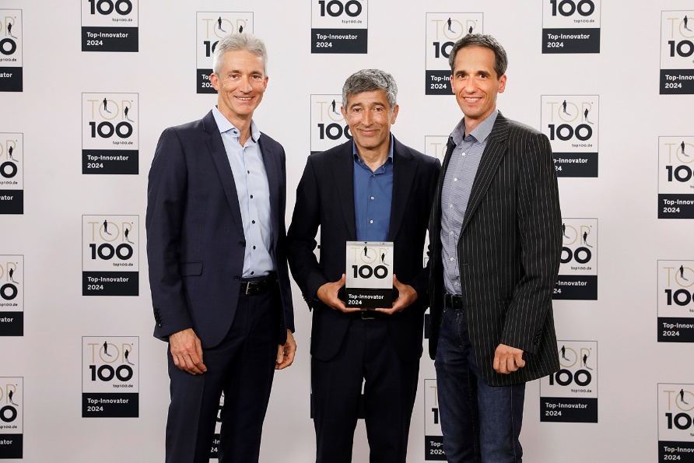 | f.l.t.r. Dr. Udo Haberland (FAULHABER), Ranga Yogeshwar (TOP 100), Frank Schwenker (FAULHABER) ©FAULHABER

Press contact (Germany + International)  Dr. Fritz Faulhaber GmbH & Co. KG  Kristina Wolff – Marketing  Faulhaberstraße 1 · 71101 Schönaich  Germany  T +49 7031 638-148 · F +49 7031 638-8148  redaktion@faulhaber.com | Press contact (Switzerland)  FAULHABER SA  Ann-Kristin Hage-Ripamonti – Marketing  6980 Croglio  Switzerland  T +41 91 61 13 239 · F +41 91 611 31 10  marketing@faulhaber.ch

